**Descriptive statistics**

Figure 1 Bar chart of the y1 variable

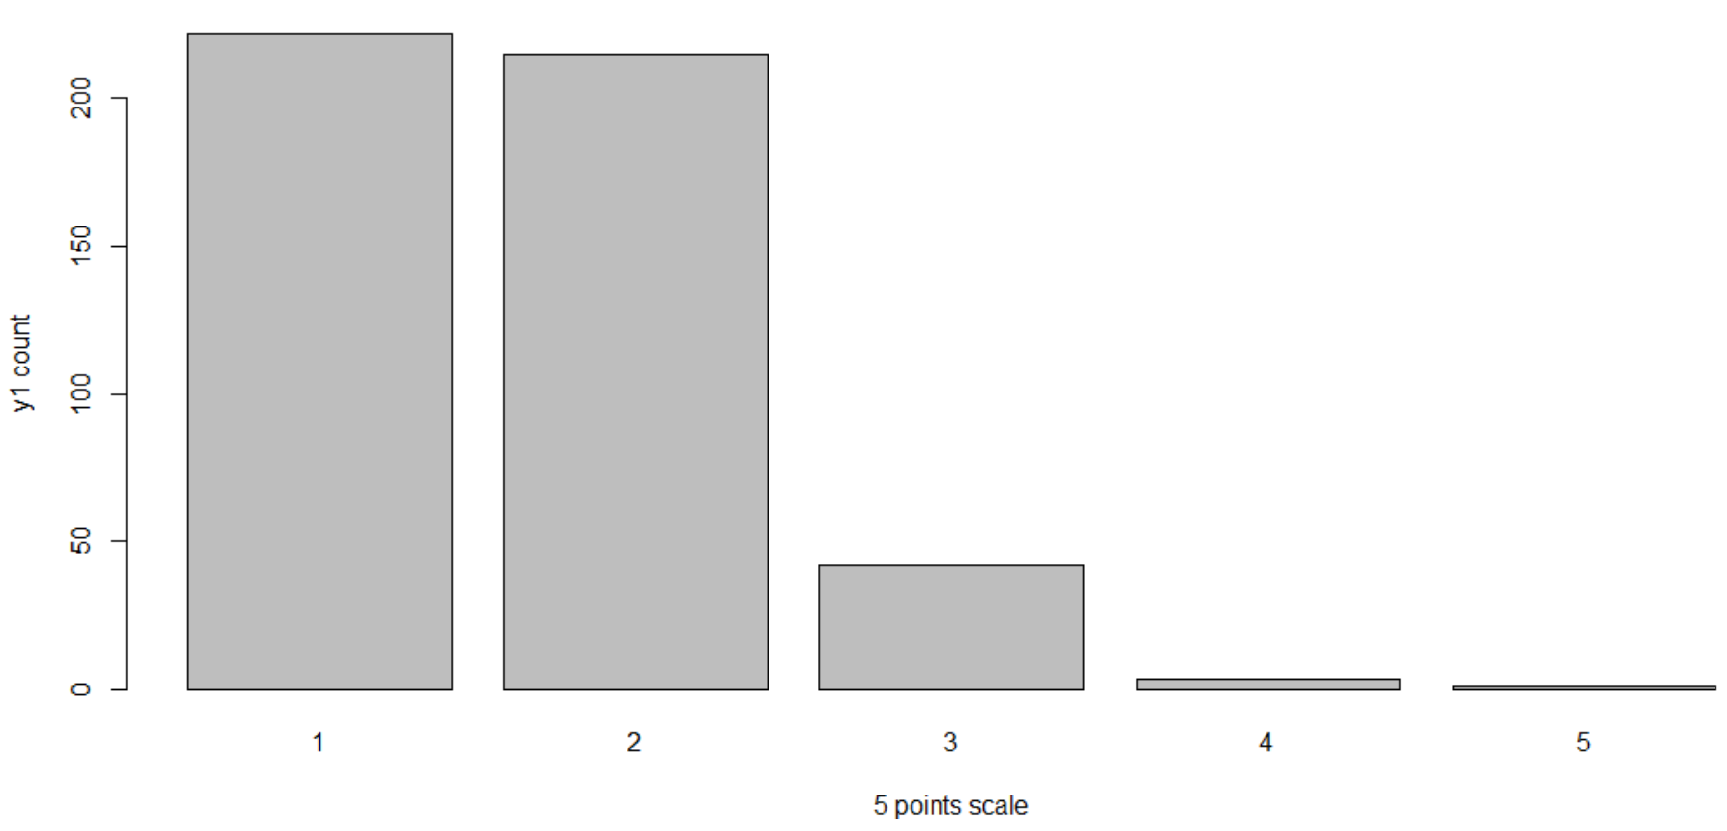

Figure 2 Bar chart for y2 variable

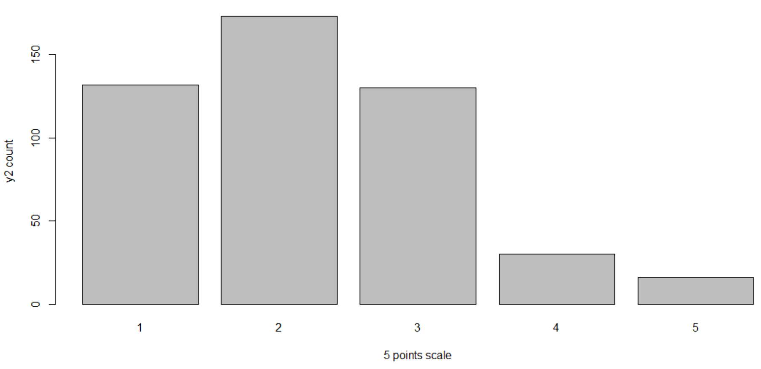

*Interpretation*

Figure 1 and 2 show that for y1 and y2 variable respondents mostly agreed with the questions because level 1 and 2 comprise the most of the responses.

**Bivariate analysis**

Figure 3: Ordinal Logistic regression for y1 and x1 to x10

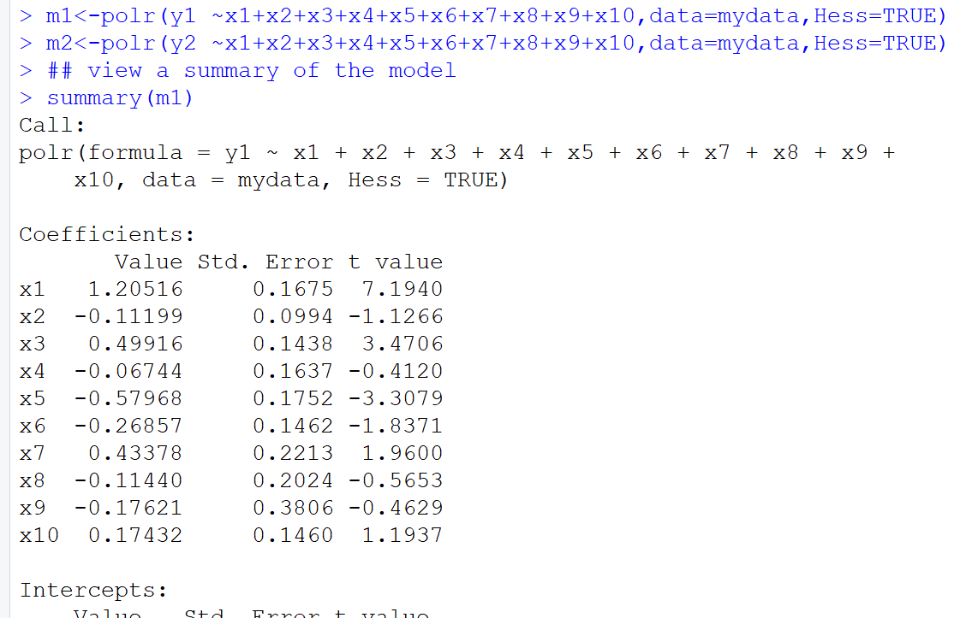

Figure 4: Ordinal Logistic regression for y1 and x1 to x10

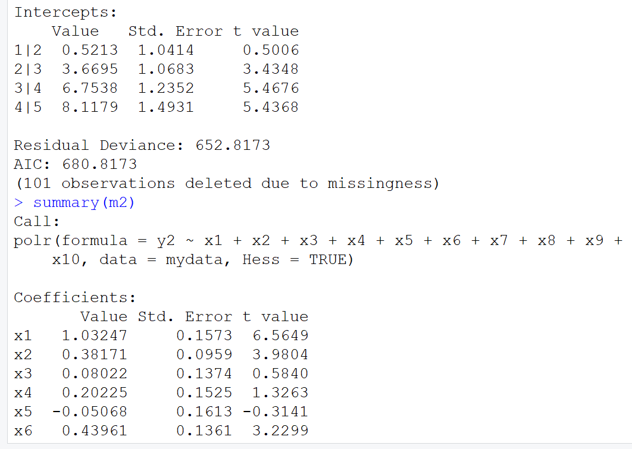

Figure 5: Ordinal Logistic regression for y1 and x1 to x10

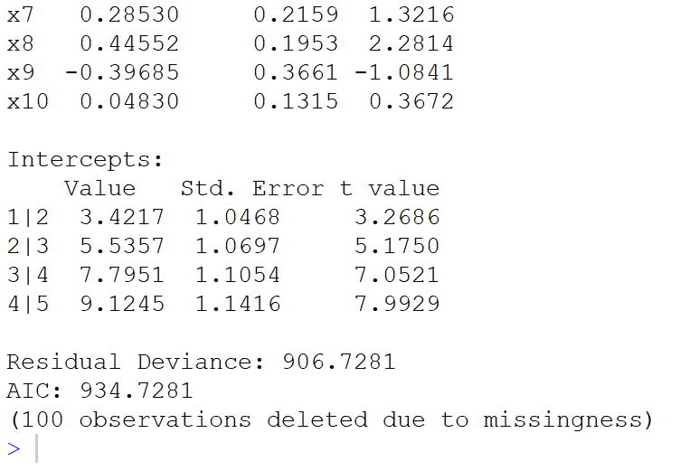

*Interpretation*

For figures 3, 4, 5 and 6, the ordinal logistic regression was used to model the impact of x1 to x10 on the variable y1 because y1 was categorical/ordinal in nature. The figures show the estimators of the regression equation named ‘value’ and test statistic t value

Figure 6: P-values for the Ordinal Logistic regression for y1 and x1 to x10

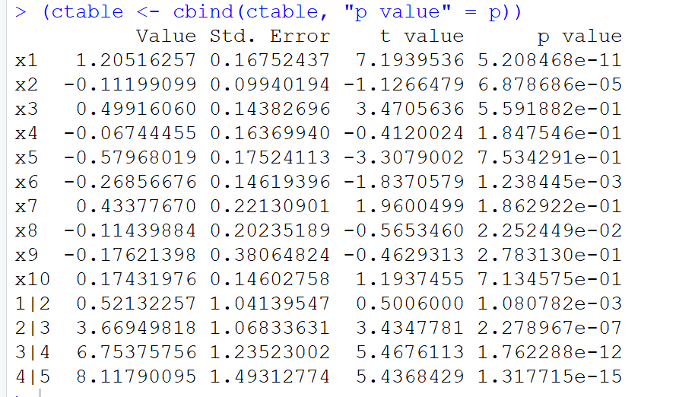

*Interpretation*

According to the p-value of the independent variables, variables; x1, x2, x6, and x8 were the only statistically significant variables because they have p-values less than 0.05 (a level of significance for rejecting the null hypothesis which suggests that no x variable affects y1)

Figure 7: P-values for the Ordinal Logistic regression for y2 and x1 to x10

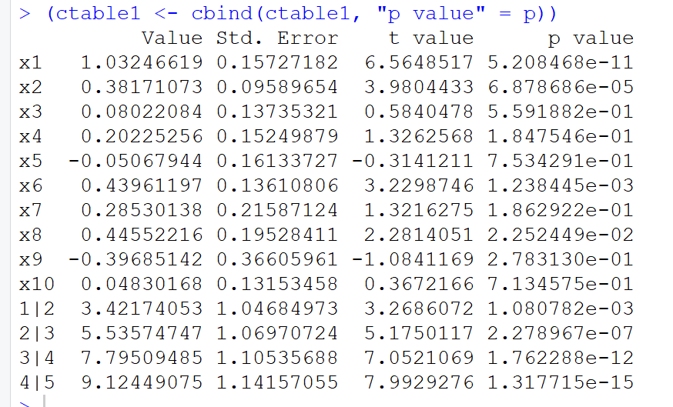

*Interpretation*

According to the p-value of the independent variables, variables; x1, x2, x6, and x8 were the only statistically significant variables because they have p-values less than 0.05 (a level of significance for rejecting the null hypothesis which suggests that no x variable affects y2)

Figure 8 Odds ratios for the coefficient of estimation for y1 (m1) and y2 (m2)

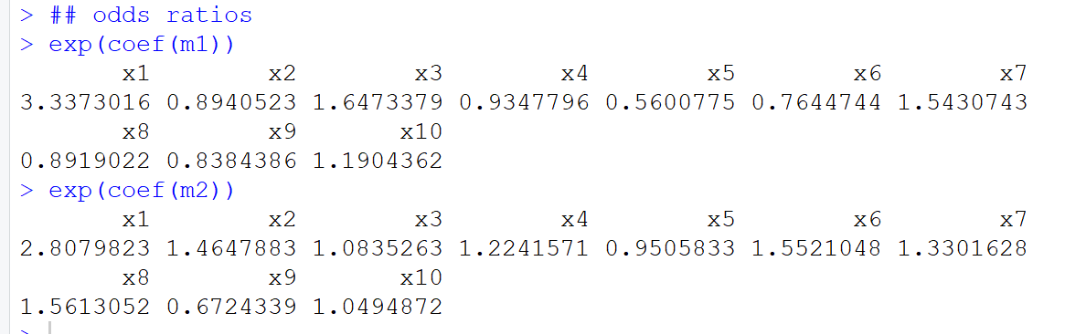

*Interpretation*

When the score of x1 increases by 1 unit, the odds of y1 approaching 5(totally disagree) increase by 3.337. When the score of x2 increases by one unit the odds of y1 approaching 5(totally disagree) increases by 0.894 and so forth.

**Multivariate analysis**

Figure 9 multivariate logistic regression for (y1, y2) against (x1 to x10)

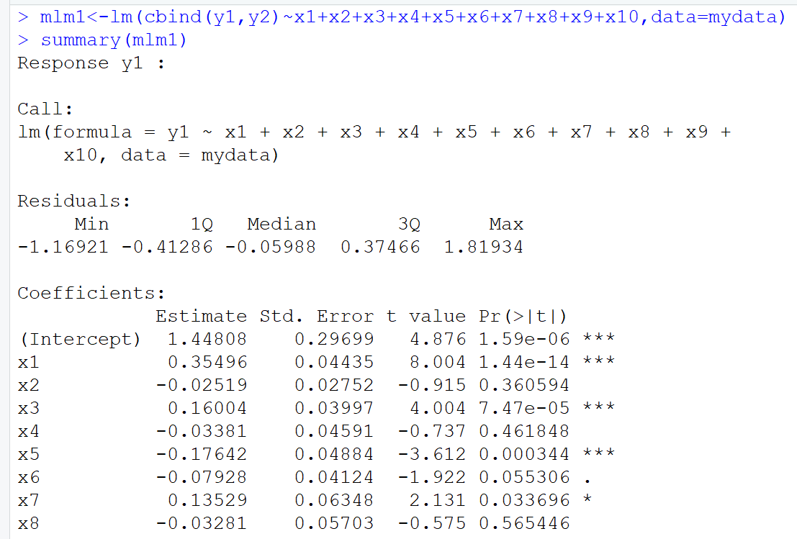

Figure 10 multivariate logistic regression for (y1, y2) against (x1 to x10)

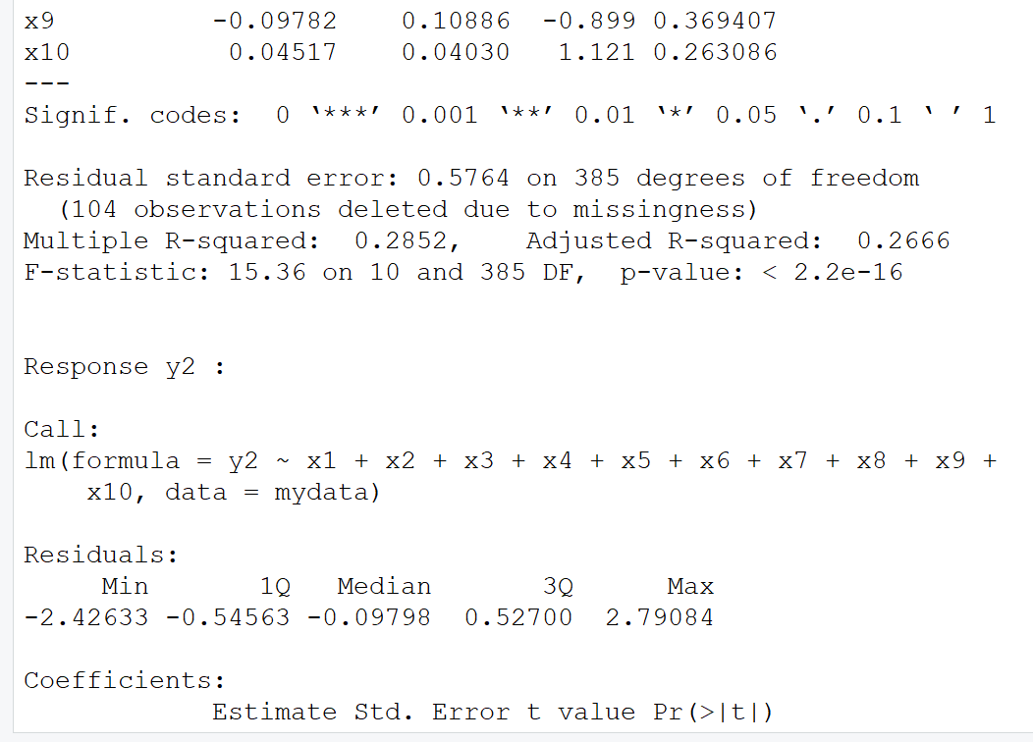

Figure 11 multivariate logistic regression for (y1, y2) against (x1 to x10)

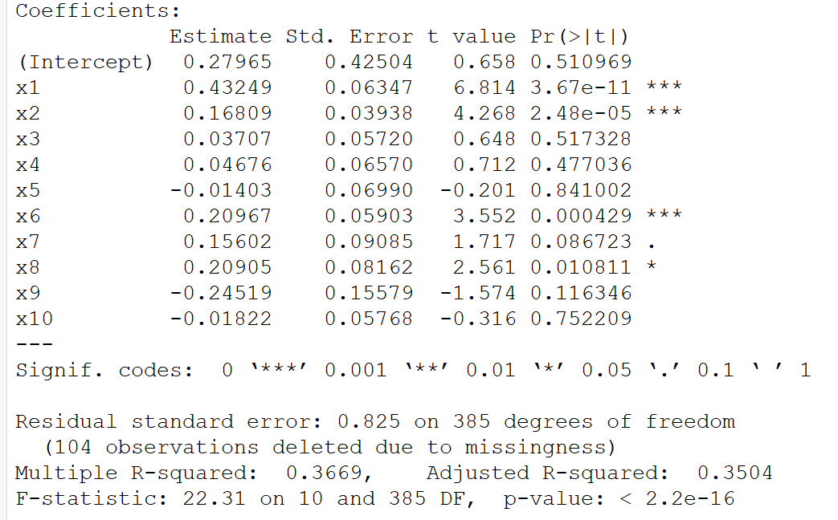

*Interpretation*

The multivariate logistic regression analysis output is shown from figure 9 to 11.The multivariate model performed logistic regression for y1 and y2 on the same output separately. Independent variables; x1, x3 and x5 variables were significant (because their p-values were less than 0.05) in explaining variation in the likelihood/odds of a respondent disagreeing with the y1 question (selecting 5). While x1, x2, x6 and x8 were significant (their p-values were less than 0.05) in explaining variation in the likelihood/odds of a respondent disagreeing with the y2 question (selecting 5). P-values are indicated as Pr (>|t|) in the output.

Figure 12 Odds ratios for multivariate logistic regression

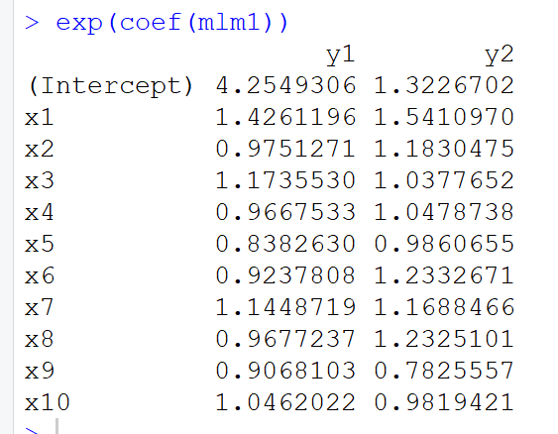

*Interpretation*

Whenever a respondent disagreed (selected a number close to 5) with question x1 given other variables were kept constant, the odds of the respondent disagreeing with question y1increases by 1.42 times While the odds for disagreeing with question y2 would increase by 1.32267 times.